1. The Internet is the biggest world-wide communication network of computers
2. an information system on the internet which allows documents to be connected to other documents by hypertext links, enabling the user to search for information by moving from one document to another
3. **What is a network** - It is a collection of computer systems and devices which are linked together using a wireless network or via communication devices and transmission media
4. **What are servers** - A server is a piece of computer hardware or software that provides functionality for other programs
5. **What are routers** - a networking device that forwards data packets between computer networks
6. **What are packets -** a network packet is a formatted unit of data carried by a packet-switched network
7. The internet is an assembly line, there are very small things that go into making one big service
8. 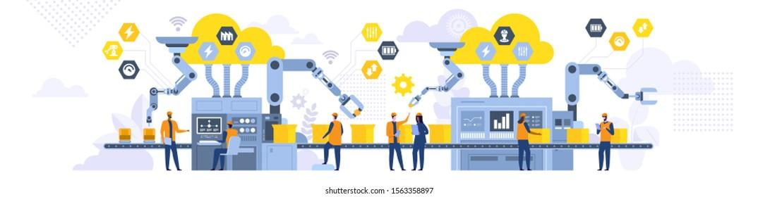

**Ip addresses & domains**

1. The IP address is an actual set of numerical instructions; the domain name functions as a link to the IP address. Links do not contain actual information, but they do point to the place where the IP address information resides
2. 104.22.13.35
3. This is important because the website can be compromised, people would probably try to hack it and mess things up

**How a web page is loaded into a browser**

1. Initial request
2. Request reaches the server
3. Browser receives HTML & starts to process
4. HTML finishes processing
5. App code finishes execution
6. Page rendered in browser